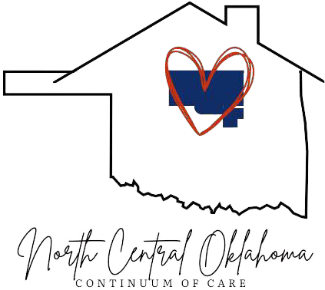

NCOCoC Lead Organization CDSA - Community Development Support Association

NCOCoC Leadership
NCOCoC Chair: Jana Nelson-MOH NCOCoC Vice Chair: Terrie Hill-Peachtree NCOCoC Secretary: Gina Caldwell
HMIS Lead: CDSA

NCOCoC HMIS Lead Agency CDSA

NCOCoC Statewide Organizations HUD- Housing
ODOC – Community Development Oklahoma DHS
Workforce Oklahoma-Employment
NCOCoC Local Organizations
A Path Forward – Ponca City, OK
CDSA, Inc. – Enid
CDSA YouthBuild Enid
City of Enid – Enid
Grand Mental Health-Stillwater Iowa Tribe
Lifegate-Sapulpa
Mission of Hope - Stillwater
Northern Ok Youth Services (NOYS) – Ponca City
OK Vet United – Tulsa
Payne Co. Youth & Services, Inc –
( P C Y S ) Stillwater
Peachtree Landing – Ponca City Survivor Resource Network (SRN) - Ponca City
The Salvation Army – Enid
United Way of Enid and Northwest Oklahoma
Wings of Hope Family Crisis Services - Stillwater
NEXT MEETING
June 5, 2025 @ 10 am
Northern Oklahoma Youth Services (NOYS)
2203 N. Ash
Ponca City, OK 74631
580-762-8341
Youth & Family Services - Enid

North Central Oklahoma Continuum of Care (NCOCoC)
The Mission of the North Central Oklahoma Continuum of Care (NCOCoC) (OK-500) is to form a seamless system of services and resources that will insure housing and community support for homeless individuals and families throughout its eight county area.
ncokcoc.org

NORTH CENTRAL OKLAHOMA CONTINUUM OF CARE BOARD MEETING
May 1, 2025 @ 10am
Mission of Hope (MOH)
1804 S. Perkins
580-233-7220

- Call to Order
- Roll Call
- Welcome and Introductions
- Agency updates
- Approval of NCOCoC Meeting Minutes
  - April 3, 2025 Meeting
Action Required
- HMIS Report
- Lead Agency Report
- Board to elect a representative to be the voting member for OK-500 for the HMIS Statewide Governance Committee
- New Business
- Adjournment

Join Zoom Meeting https://us02web.zoom.us/j/88194489708?pwd=YkdHY0tsYUU0a2RlM0dqbDdCZ1pNZz09
Meeting ID: 88194489708
Passcode: 211873

